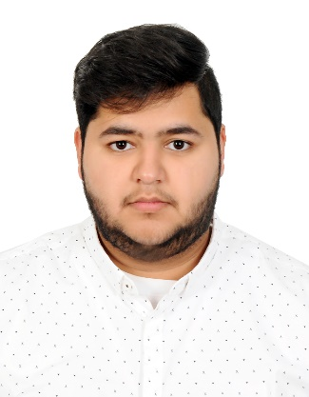

**Ameer Khaled Mohamed Ali**

**Address:** Flat 2, Building 2465, Road 979, Block 709,

Isa Town, Kingdom of Bahrain

**Phone:** (+973) 66999781

**Email:** ameer.paidkhani@gmail.com

**OBJECTIVE**

I am seeking an opportunity to use my experience, energy and enthusiasm, and would welcome the challenge of working in a dynamic company where I can use my abilities and qualification to achieve optimum results.

**EXPERIENCE**

* **2019** Worked as a Promoter for Shop Bahrain 2019.
* **2016** Worked as an Organizer in Animania Bahrain Convention.
* **2015** Worked as a Salesman for five months in a retail outlet.
* **2015** Community Service Certificate in Administrative Supervision from my high school.

**EDUCATION**

* **2016** Graduated from Isa Town Secondary School.
* **2016** Studied One Semester English Foundation.
* **2015** A9eel Program Certificate.
* **2009** English Language Course of AL-Hadith Institute.

**SKILLS**

* Initiative with a high level of energy.
* Ability to work under pressure
* Tolerant and adaptable to different situations.
* Exceeding expected results through delivering high quality work before set deadlines.
* Detail oriented, high degree of accuracy.
* High ability to work in groups and a key contributor in team work.
* Excellent knowledge of MS Word, MS Excel, MS PowerPoint and internet.
* Fluent in English, written and spoken. Fluent in Arabic, written and spoken.

**INTERESTS**

* Reading
* Learning
* Sports

**PERSONAL INFORMATION**

**Date of Birth:** 14th Oct 1998 **Nationality:** Bahraini

**CPR Number:** 981004369 **Marital Status:** Single

**References available on request**